**Summary of key insights: Topic modelling with Reddit to understand study abroad preferences of Indian students**

1. **Topic interests gathered across countries**

This figure examines the proportion of posts discussing seven key topics related to studying abroad across the top five countries. Strongest focus areas for the top 5 countries are:

* Australia - Career & Jobs and Funding & Financial Support
* United Kingdom - Student Experience, Admission Criteria, and Post-Study Migration Plans.
* Germany - Student Experience and Application Essentials.
* United States - Visa & Immigration, though less focus is placed on funding and post-study opportunities.
* Canada - Application Essentials and Student Experience

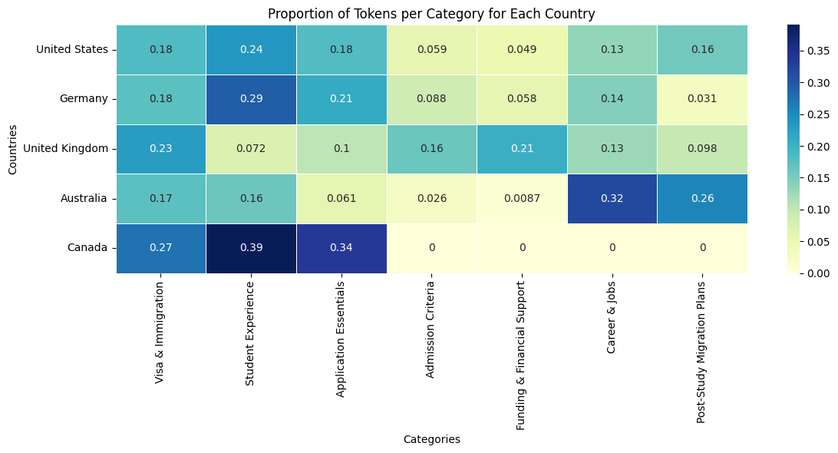

The next section presents results from a sentiment decomposition of the focus areas. This is to delve deeper on understanding perceptions about these focus areas and comparing them across countries. Here I focus on 4 categories related to costs and jobs which I am most interested in - Cost of Living, Tuition & Fees, Financial Aid & Scholarships, and Work & Funding Opportunities.

1. **Heatmap Analysis: Understanding the Sentiment Landscape**

**Narrative**: For Indian students, the **USA** and **UK** are seen as appealing for work opportunities, but the high costs of living and tuition weigh heavily on perceptions. In contrast, **Australia** and **Canada** strike a balance between work prospects and affordability, while **Germany** is a clear favorite for cost-conscious students seeking affordable education with great scholarship support.

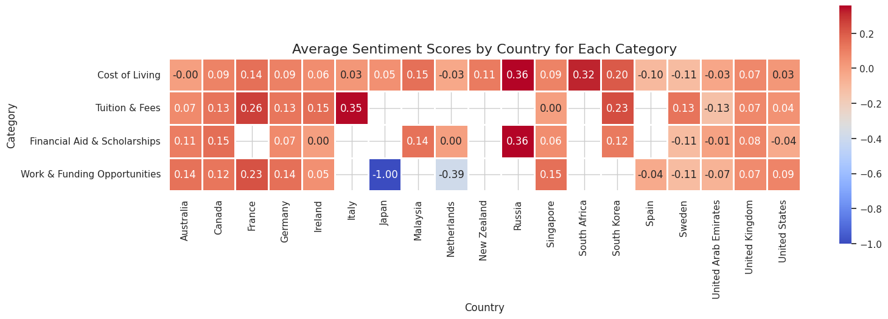

The heatmap presents a broad overview of how Indian students perceive different aspects of studying abroad, categorized by **Cost of Living**, **Tuition & Fees**, **Financial Aid & Scholarships**, and **Work & Funding Opportunities** across several countries. The sentiment scale ranges from negative (blue) to positive (red), with neutral tones in between.

**Key Insights**:

* **USA** stands out for its **negative perceptions of costs**—both **Cost of Living** and **Tuition & Fees** receive negative sentiment scores, suggesting that many students find the financial burden challenging. Despite these concerns, the **Work & Funding Opportunities** category is notably positive, highlighting the appeal of the job market in the USA, possibly driven by its post-graduation work programs (e.g., OPT).
* **UK** follows a similar pattern, where **Cost of Living** and **Tuition & Fees** are slightly negative to neutral, but **Work & Funding Opportunities** sees moderate positive sentiment. This suggests that, while the UK may be seen as expensive, students appreciate the potential for work during and after studies.
* **Australia** appears **neutral to positive** in most areas. The **Cost of Living** and **Tuition & Fees** categories have a more balanced sentiment, while **Work & Funding Opportunities** stands out with a notable positive sentiment score. Australia’s post-study work visa policies and job prospects seem to resonate well with prospective students.
* **Canada** is **overall positive**. High positive sentiment in **Financial Aid & Scholarships** and **Work & Funding Opportunities** suggests that Canada’s appeal lies in its affordability and strong job prospects, especially with its accessible immigration policies.
* **Germany** stands as a top contender for **cost-conscious students**, with positive sentiment across most categories, particularly **Financial Aid & Scholarships** and **Tuition & Fees**. Germany is seen as a cost-effective destination, offering relatively low tuition fees and good scholarship opportunities.

1. **Spider Plot Analysis: A Bird’s-eye View of Country Sentiment**

**Narrative**: In the **spider plots**, the **USA**’s shape reflects the dilemma students face: high costs but appealing work opportunities. The **UK** and **Australia** offer more balanced experiences, while **Canada** presents an attractive, well-rounded option. **Germany** consistently emerges as a solid, cost-effective destination with strong support systems.

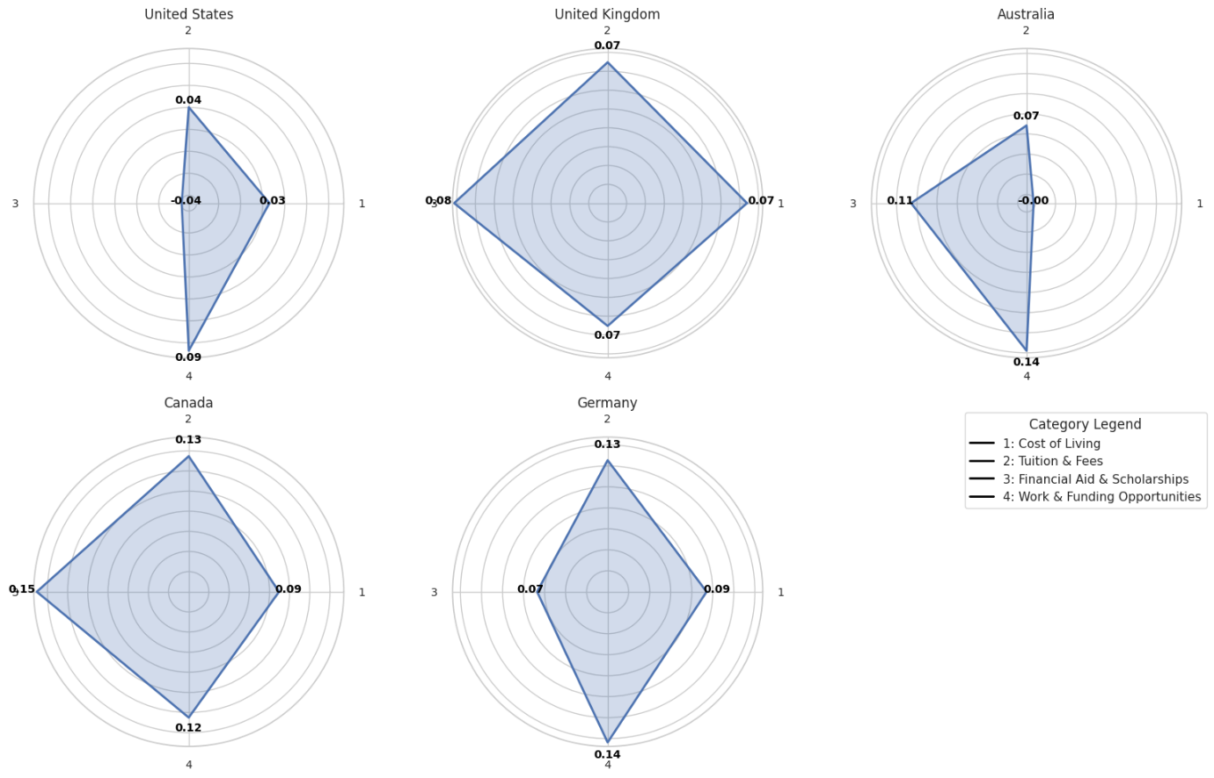

The spider plots offer a more visual and intuitive comparison of sentiment across the four categories for the top five countries. Each country is represented by a polygon, and the sentiment scores for each category (Cost of Living, Tuition & Fees, Financial Aid & Scholarships, and Work & Funding Opportunities) are plotted along the axes.

**Key Insights**:

* **USA**: The USA’s plot reveals a **triangular** shape, indicating a **strong negative sentiment towards costs** (living and tuition) while a **positive perception of work opportunities**. This aligns with the heatmap insights—students acknowledge the high costs but are drawn to the potential job opportunities available post-graduation.
* **UK**: The **balanced** shape of the UK’s plot indicates **neutral to positive perceptions** across most categories, with a slight positive lean in **Work & Funding Opportunities**. The UK offers a well-rounded experience but does not stand out in terms of cost effectiveness.
* **Australia**: The **spike** in **Work & Funding Opportunities** is the most prominent feature of Australia’s plot. This suggests that students are drawn to Australia for post-graduation employment prospects, but **Cost of Living** and **Tuition Fees** are areas of concern, although not as heavily negative as in the USA or UK.
* **Canada**: **Canada** exhibits a **positive and balanced** distribution, with **Financial Aid & Scholarships** standing out. This indicates that Canada is seen as affordable and supportive, both in terms of financial aid and career opportunities, making it a top choice for students seeking value for money.
* **Germany**: The **even and positive shape** of Germany’s plot highlights **affordability** and **strong financial aid support**, with **neutral to positive sentiment** across all categories. Germany continues to be a top choice for students looking for a solid education experience with minimal financial strain.

1. **Stacked Bar Plot Analysis: Proportions of Positive, Neutral, and Negative Sentiments**

**Narrative**: Countries like the **USA** and **UK** face high costs, but work opportunities remain a significant draw. **Australia** and **Canada** find a balance, with **Canada** leading in terms of affordability and support. **Germany** remains the most positive across all categories, especially with its low-cost structure and strong financial aid offerings.

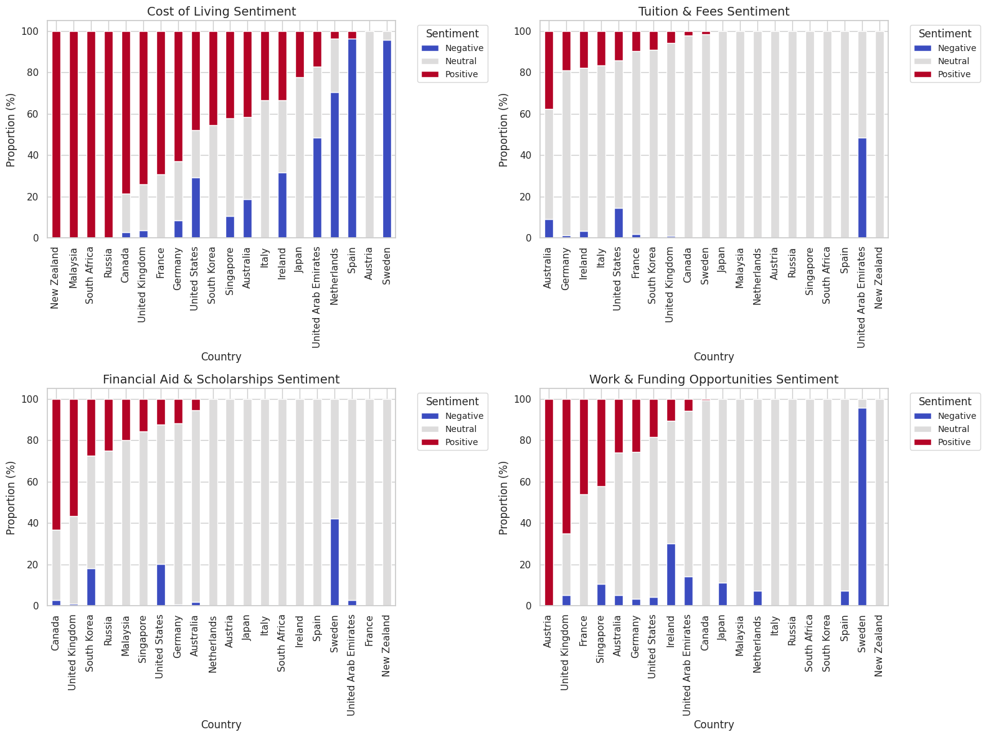

The stacked bar plots illustrate the proportion of **positive**, **neutral**, and **negative** sentiments for each category across countries, providing a clearer view of the overall sentiment distribution.

**Key Insights**:

* **USA**: The **Cost of Living** and **Tuition & Fees** categories show a **majority negative sentiment**, reinforcing the idea that high tuition and living costs are significant barriers. However, **Work & Funding Opportunities** stands out with a **high proportion of positive sentiment**, signaling that students remain optimistic about career prospects despite financial challenges.
* **UK**: Like the USA, the **Cost of Living** and **Tuition & Fees** categories are primarily **negative** or **neutral**, but **Work & Funding Opportunities** again sees a higher proportion of **positive sentiment**. This suggests that, like the USA, the UK is attractive for work but less so for financial affordability.
* **Australia**: The **Cost of Living** and **Tuition & Fees** categories display a mix of **neutral and negative** sentiments, but **Work & Funding Opportunities** again emerges as a positive area, showing that students feel more optimistic about employment prospects in Australia than about its costs.
* **Canada**: The most **positive** country in terms of **Financial Aid & Scholarships** sentiment, with a clear **majority positive** sentiment in this category, as well as a more **neutral to positive** sentiment overall in **Cost of Living** and **Work & Funding Opportunities**. This reinforces Canada’s reputation as a financially attractive destination.
* **Germany**: The **negative** sentiment is minimal in all categories, particularly **Cost of Living** and **Tuition & Fees**, confirming Germany’s status as an affordable and financially supportive option. The high proportion of **positive sentiment** in all categories speaks to its attractiveness for students seeking value.

**Conclusion**

By analyzing these three plots together, we get a comprehensive picture of how prospective students perceive the costs and opportunities associated with studying abroad in various countries. **The USA** and **UK** face challenges in terms of costs but are still highly regarded for their work opportunities. **Australia** and **Canada** strike a balance between cost and opportunity, while **Germany** emerges as the most affordable and well-supported destination for cost-conscious students.